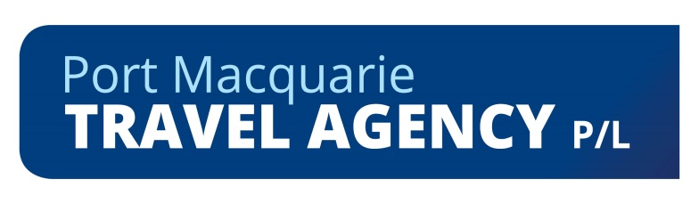
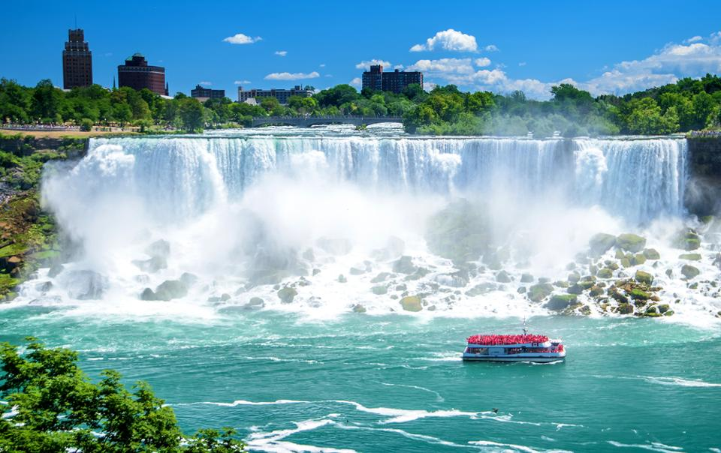

Eastern Canada

New England and New York

Escorted by Sonya Wheatley

24 Spectacular Days – Departing 26th August 2021

Thursday 26 August Home to Sydney

You will be picked up from your front door (within a 35km radius of Port Macquarie) and transferred to Port Macquarie airport for your flight to Sydney

Qantaslink Flight # Departing Port Macquarie TBA Economy Class
QF Arriving Sydney at TBA
You will be transferred to Rydges Hotel Sydney Airport for our overnight stay – Breakfast included
Join your fellow travellers in the bar for a get-together 5.00pm (own expense)

Friday 27 August Sydney to Toronto

Air Canada Flight # Departing Sydney TBA Economy Class
AC Arriving Toronto at TBA
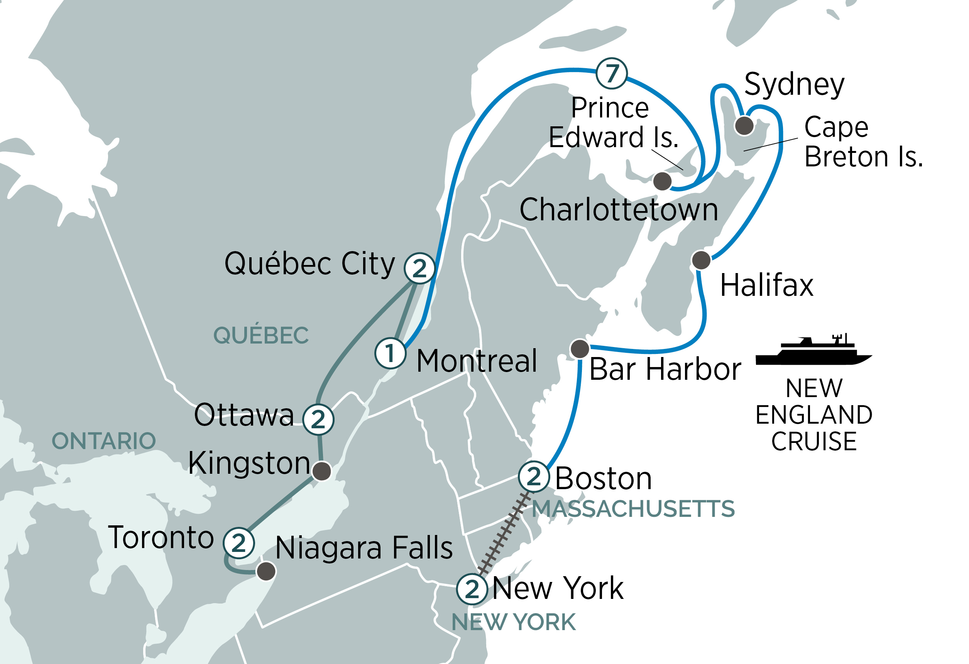
Arrive Toronto
Welcome to Canada! On arrival at Toronto International Airport, you will be met and transferred to your downtown hotel. Toronto is a cosmopolitan city, and is the cultural, entertainment and financial capital of Canada.
Three Night Stay: Westin Harbour Castle

Saturday 28 August Toronto at leisure
Today enjoy a free day in Toronto exploring the cities highlights
Discover More: Dinner cruise on Toronto Harbour (extra expense)

Sunday 29 August Niagara Falls
Today, you will see one of the most spectacular natural sights of North America as you visit the incredible Niagara Falls. Travel through the countryside before arriving at Niagara for a thrilling cruise to the foot of Horseshoe Falls. Get up close to one of the most amazing waterfalls in the world as you feel the mist washing over you. After some free time or an optional helicopter ride over the falls, visit the historic and beautifully preserved village of Niagara-on-the-Lake before returning to Toronto early this evening. Tonight, enjoy a welcome dinner.
Discover More: Experience a spectacular helicopter flight over the falls (extra expense)
Meals Included: Breakfast, Dinner

Monday 30 August Toronto – Kingston – Ottawa
This morning, take a journey to the top of CN Tower, the tallest free-standing tower in the Americas for some spectacular views over Toronto. Travel up University Avenue to take in the sights of Ontario’s Parliament Buildings, Queens Park and museum row. Travel east following Lake Ontario to the colonial city of Kingston, the gateway to the beautiful Thousand Islands region of the St. Lawrence River. Board your vessel for a cruise of one of the most picturesque areas in Eastern Canada. Travel through the islands and canals and view spectacular old buildings, attractive neighbourhoods and abundant birdlife. Continue following the rivers and lakes to Canada’s capital.
Two Night Stay: The Westin Ottawa or similar. Meals Included: Breakfast

Tuesday 31 August Ottawa Sightseeing
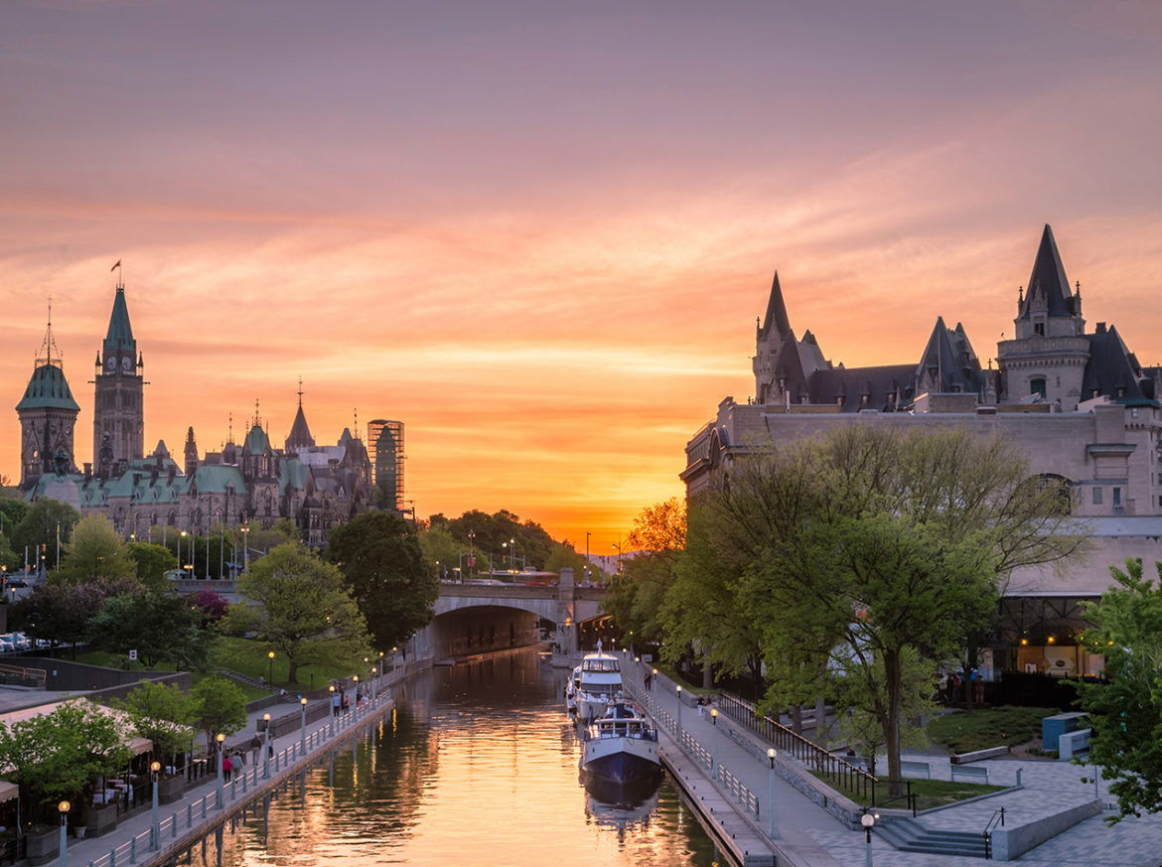
This morning, our local guide joins us for a tour of Ottawa, famous for its stately boulevards, imposing buildings and tulip filled gardens during spring. See the green-peaked roofs of the Parliament Buildings, City Hall and the National Gallery. We view the residences of the Prime Minister and the Governor General, the Royal Canadian Mint and the Rideau Canal. Take a break at Byward Market where you have free time to explore before continuing your city tour with a visit to the Canadian Museum of History, Canada’s largest and most popular cultural institution. You’re Invited: Visit a First Nations camp at the Canadian Museum of History where you will partake in an informative tour of the Native village, then witness a vibrant performance of traditional styles of Pow Wow dancing. Tonight, dine at the National Arts Centre. Dedicated to the performing arts, this is a culinary experience that indulges the senses.
Meals Included: Breakfast, Dinner

Wednesday 1 September Ottawa – Quebec City
Bienvenue! Welcome to the French-Canadian province of Quebec. Make your way to a traditional Quebecois Sugar Shack. You’re Invited: Enjoy French Canadian country charm and hospitality and learn how to make maple candy, then partake in a delicious lunch that showcases the local country cuisine. Visit Deschambault a quaint village along the St. Lawrence River before a scenic drive along the “Chemin du Roy” (King’s Road), the oldest roadway in Canada. This historic “New France Route,” takes you to Quebec City, the UNESCO World Heritage Site spectacularly perched atop Cap Diamant. French is the primary language in this unique city, founded in 1608 as a trading post. Arrive into Quebec City in the afternoon and meet our local guide for a tour of The Plains of Abraham, the Citadel and Parliament buildings. You will then embark on a walking tour within the walls of the Vieux Carré (Old City) and visit Lower Town. This is truly a remarkable city, every building in Old Quebec tells a story and every square exudes the spirit of New France with a history dating back many hundreds of years.
Two Night Stay: Hotel Clarendon Meals Included: Breakfast, Lunch, Dinner
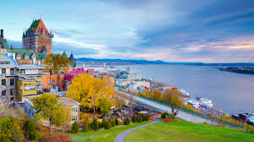
Thursday 2 September Quebec City
Quebec City is one of the world’s most historical and fascinating cities. Spend the day exploring the quaint streets, ancient buildings and getting to know the local food and people.
Discover More: Savour the local cuisine on a gastronomic walking tour (extra expense)
Meals Included: Breakfast

Friday 3 September Quebec City – Montreal
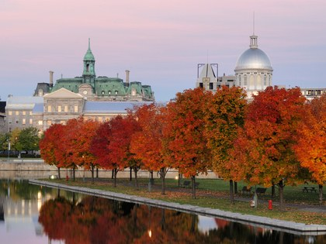
Leaving old-world Quebec, travel along the St. Lawrence River. Head for the quintessentially French city of Montreal, located on an island of the St. Lawrence River. On arrival, enjoy a sightseeing tour of the city, viewing the Olympic Complex, St. Joseph’s Oratory, Notre Dame Cathedral and views of the city skyline from the parklands of Mt. Royal. Montreal abounds with sightseeing options, such as taking a stroll, bicycle or a horse-drawn carriage through the narrow cobblestone streets of the famous Parisian-style historic district, which is filled with cultural landmarks, museums, boutiques and restaurants.
Overnight Stay: Novotel Montreal Meals Included: Breakfast, Dinner

Saturday 4 September New England Discovery – 7 Night Cruise
This morning, transfer to the pier to board your luxurious cruise ship. Check into your comfortable ocean view stateroom (upgrade to verandah stateroom additional expense) on the Holland America cruise ship ms Zaandam or ms Amsterdam. Settle-in for an unforgettable 7 night voyage through the St. Lawrence River and New England. Meals Included: Breakfast, Dinner

Sunday 5 September Quebec City
Early this morning, our cruise ship will dock in Quebec City. There are a wide range of shore excursions available (own expense).
Meals Included: Breakfast, Lunch, Dinner

Monday 6 September Gulf of St. Lawrence
The largest estuary in the world, the Gulf of Saint Lawrence fringes the shores of half the provinces of Canada and is a gateway to the interior of the entire North American continent. Geographically, the Gulf is defined by stunning coast line and beautiful islands, including Prince Edward Island and the Magdalen Islands. Thousands of migratory birds make this area their home during the spring and autumn migration period.
Meals Included: Breakfast, Lunch, Dinner

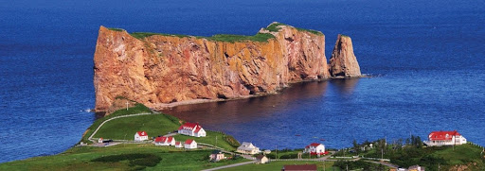

Tuesday 7 September Charlottetown, Prince Edward Island
This morning, arrive into the charming city of Charlottetown on Prince Edward Island. There is plenty of free time to explore the city famed for being the birthplace of Canada. Be sure to visit Confederation Centre or perhaps enjoy an optional tour to the ‘Anne of Green Gables’ homesite (own expense).
Meals Included: Breakfast, Lunch, Dinner

Wednesday 8 September Sydney, Cape Breton Island
A hundred thousand Gaelic welcomes await you in Nova Scotia. At the northeast end of the province sits Cape Breton Island, whose wild and lovely topography includes Cape Breton Highlands National Park, Bras d’Or Lake, and miles of rugged coastline. Sydney is the gateway to it all. Spend the day in Sydney or take an optional sightseeing tour (shore excursions are at own expense).
Meals Included: Breakfast, Lunch, Dinner
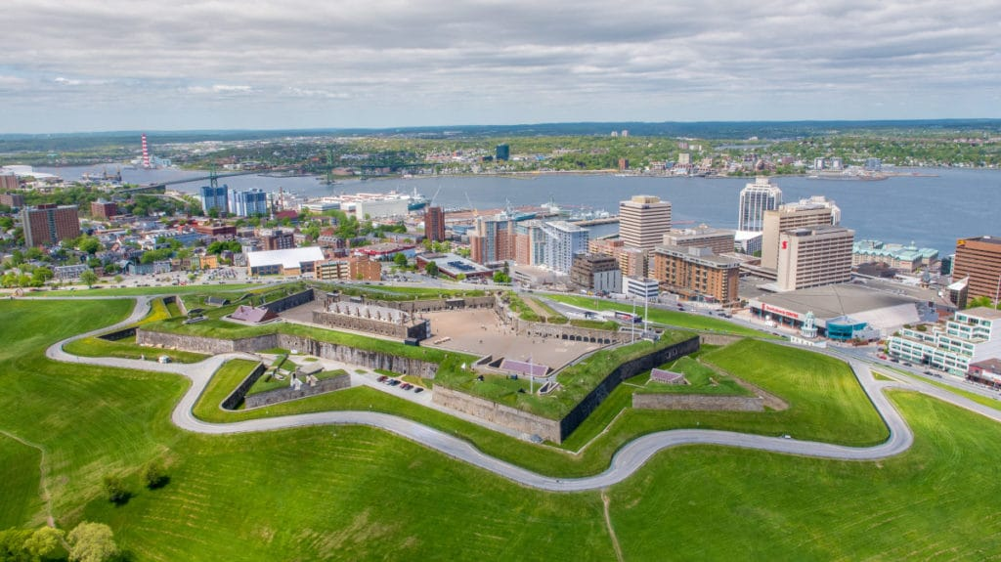
Thursday 9 September Halifax, Nova Scotia
Arrive into Halifax this morning and spend the day docked in one of the world’s most beautiful natural harbours. Explore this fascinating and historic city on your own or perhaps take an optional tour to delightful Peggy’s Cove, possibly the most photographed village in Canada (shore excursions at own expense).
Meals Included: Breakfast, Lunch, Dinner

Friday 10 September Bar Harbor, Maine
Enter the waters of the United States as you sail along the coast of New Brunswick and past Grand Manan Island. Arrive into Bar Harbor, from where optional tours will be available into the beautiful Acadia National Park (own expense).
Meals Included: Breakfast, Lunch, Dinner

Saturday 11 September Boston Sightseeing
Arrive into the city of Boston early this morning. After disembarking the ship, you will be joined by a local guide for a walk along the Freedom Trail. See Boston Common, Faneuil Hall and the Old State House. The rest of the day is at leisure for you to explore Boston.
Two Night Stay: Sheraton Boston or similar Meals Included: Breakfast, Dinner

Sunday 12 September Boston
After breakfast, the day is at leisure for you to explore more of one of America’s oldest and most historic cities.
Discover More: Explore Boston with the unique Boston Duck Tours, or discover the city on an Old Town Trolley tour (extra expense)
Meals Included: Breakfast

Monday 13 September Boston – New York City
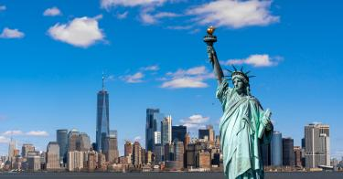
Today’s journey takes us to the railway station where we board the Amtrak train to New York. Settle into your business class seats and enjoy this popular journey. A visit to the bustling and iconic “Big Apple” is a must on any trip to the USA and this thriving city will no doubt live up to it’s reputation.
Three Night Stay: New York Hilton Midtown
Discover More: Take an elegant dinner cruise on the Bateau
New York (extra expense)
Meals Included: Breakfast

Tuesday 14 September New York City Sightseeing
Discover New York City at your own pace with an included Hop-On Hop-Off Double Decker Bus Tour. Your ticket will allow you to explore over 50 stops throughout Manhattan and Brooklyn, from The United Nations to Times Square, from Harlem to Battery Park, including the ferry to the Statue of Liberty. This evening, enjoy a farewell dinner.
Meals Included: Breakfast, Dinner

Wednesday 15 September New York
A free day to explore New York at leisure

Thursday 16 September New York to Sydney
Transfer to the airport for your homeward flight.
Meals Included: Breakfast

Air Canada Flight # Departing New York TBA Economy Class
AC Arrive in Vancouver
Air Canada Flight Depart Vancouver TBA Economy Class
Saturday 18 September Arrive in Sydney
Arrive Sydney
Qantaslink Flight # Departing Sydney TBA Economy Class
QF Arriving Port Macquarie TBA
On arrival in Port Macquarie you will be transferred to your home

INCLUSIONS:
- Return transfers from your front door within 35 kms of Port Macquarie
- Escorted throughout (subject to minimum numbers being met for group - if minimum numbers are not met you will be escorted to Sydney and then met by an Evergreen representative on arrival in Toronto)
- Return flights from Port Macquarie to Sydney
- 1 Night Accommodation at Rydges Sydney Airport with Breakfast
- Economy flights with Air Canada as specified on itinerary (times subject to change)
- Meals as indicated (B = breakfast, L = lunch, D = dinner)
- ESTA visa for USA and ETA visa for Canada

Evergreen tours inclusions
- The services of an Evergreen Tour Director
- 8 Day Eastern Canada Experience plus and additional night in Toronto
- 7 Nights on a luxury cruise ship – Holland America Line ms Zaandam Oceanview cabin category E
- 5 Day Eastern USA Experience plus an additional night in New York
- Premium First Class hotels including all hotel service charges and porterage
- Return airport transfers
- Port taxes and charges
- All tipping and gratuities
- Discover New York City with a Hop-On Hop-Off Double Decker Bus Tour including a cruise to The Statue of Liberty
- See Niagara Falls up-close on an exciting cruise
- Learn of Boston’s fascinating history on a guided walk of the Freedom Trail
- Rise to the Top of CN Tower, the tallest free-standing tower in North America
- Guided walking tour inside Old Quebec City, plus see the Plains of Abraham, the Citadel and the historic walls of Quebec City
- Visit the port of Bar Harbor in Maine
- Guided tour of the sights of Montreal including the intricate architecture of Notre-Dame Cathedral and panoramic views of the city from Mount Royal
- Discover Toronto’s famous sights including museum row, Queen’s Park, Parliament Buildings and City Hall
- Sightseeing tour of the nation’s capital, Ottawa to see the Parliament Buildings and explore 2,000 years of human history at the Canadian Museum of History
- Enjoy the spectacular scenery on a 1000 islands cruise
- Take in the famous streets and sights of New York City
- Enjoy scenic cruising of the St. Lawrence River & the Gulf of St Lawrence
- Visit the port of Charlottetown on the famous Prince Edward Island
- Visit the ports of Halifax and Sydney, and explore the raw and beautiful scenery in Nova Scotia

DINING HIGHLIGHTS
- 38 superb meals including: 18 Full Breakfasts (FB), 6 Lunches (L), 1 Highlight Lunch (HL) & 13 Dinners (D)
- Dinner at the National Arts Centre in Ottawa
- Welcome and farewell dinners

YOU’RE INVITED
Experience true French Canadian hospitality at a traditional sugar shack with lunch
Learn about the local native culture and enjoy a vibrant performance in Ottawa

EXCLUSIONS:
- Not Included in the Cost - All items of a personal nature such as telephone calls, drinks, excess baggage, tips, meals, (except those specified in the itinerary)
- Travel insurance – Compulsory

$13835.00 PER PERSON —TWIN SHARE
An Early bird discount of $1000.00 per person is available
for bookings confirmed prior to the 31st May 2020
subject to availability of offer

Deposit $2,000.00 per person due at time of booking
Final payment due date – 30th March 2021



TERMS AND CONDITIONS - CANCELLATION SCHEDULE AND FEES
Please refer to the Terms and Conditions of Evergreen tours in their Evergreen Canada and Alaska brochure – if you would like a copy please give us a call.

The tour will be escorted from Port Macquarie provided minimum group numbers of 16 or more are met. In the event that we are unable to reach the required numbers you will be escorted from Port Macquarie to join your Air Canada flight and will be met in Canada by an Evergreen representative.

As the tour is for 2021 there may be some minor changes required to the itinerary, hotels or touring and these will be advised as soon as they are confirmed

If bookings are cancelled the following cancellation fees will apply

Deposit is non-refundable
90 to 62 days – 50% of Tour price
61 days or less - no refund

Please ensure Insurance is taken out to cover in the event of cancellation.
Please ask us for a quote for Travel Insurance

PORT MACQUARIE TRAVEL
114 William Street, Port Macquarie NSW 2444
Phone: 02 65831422 Fax: 02 65841037
ABN: 30001435187

CAMDEN HAVEN TRAVEL AND CRUISE
Shop 4, 75 Bold Street, Laurieton NSW 2443
Phone: 02 65599048 Fax: 02 65598996

